PATHSHALA NEPAL FOUNDATION

PRE-UNI PROGRAM

Baneshwor, Kathmandu



Lab assessment report on

Function in C

**Submitted By:** **Submitted To:**

Name: Raunak Raj Adhikari Department of Computer Science

Class: 12 PATHSHALA NEPAL FOUNDATION

Group: 2

Date: 2023-07-29

**Answer the following questions:**

1. Define function. Show the differences between built-in function and user-defined function with examples.

|  |  |  |
| --- | --- | --- |
| S.N. | Build-In Function | User-Defined Function |
| 1 |  |  |
| 2 |  |  |
| 3 |  |  |
| 4 |  |  |
| Ex: |  |  |

1. Why are functions essential to create? Discuss briefly.
2. List the features of functions.
3. Mention different types of user-defined functions with syntax and examples.

**Develop C program using functions:**

1.

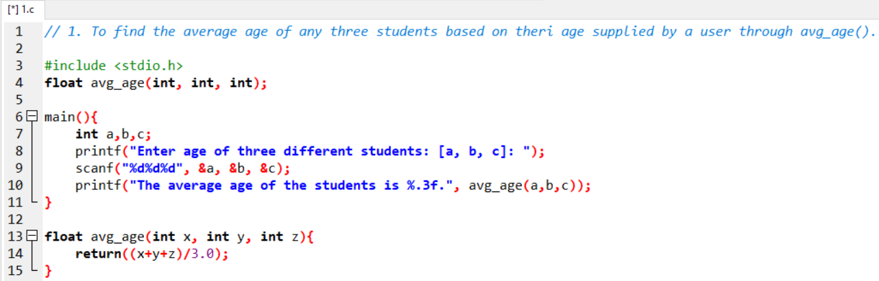

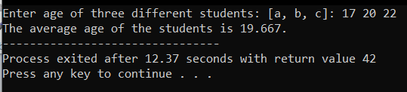

2.

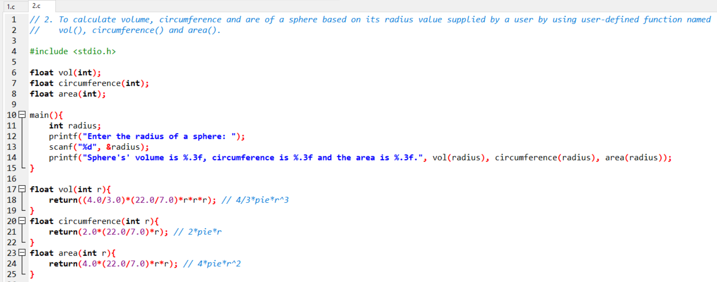

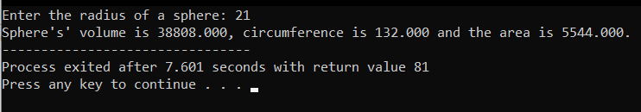

3.

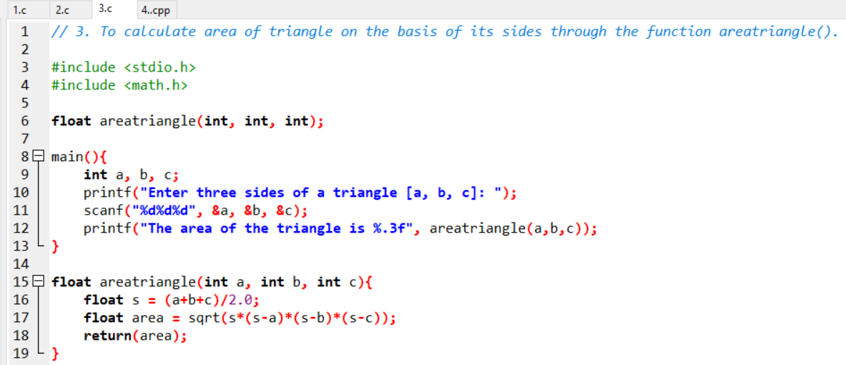

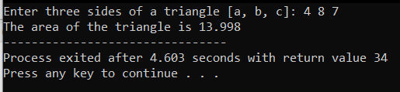

4.

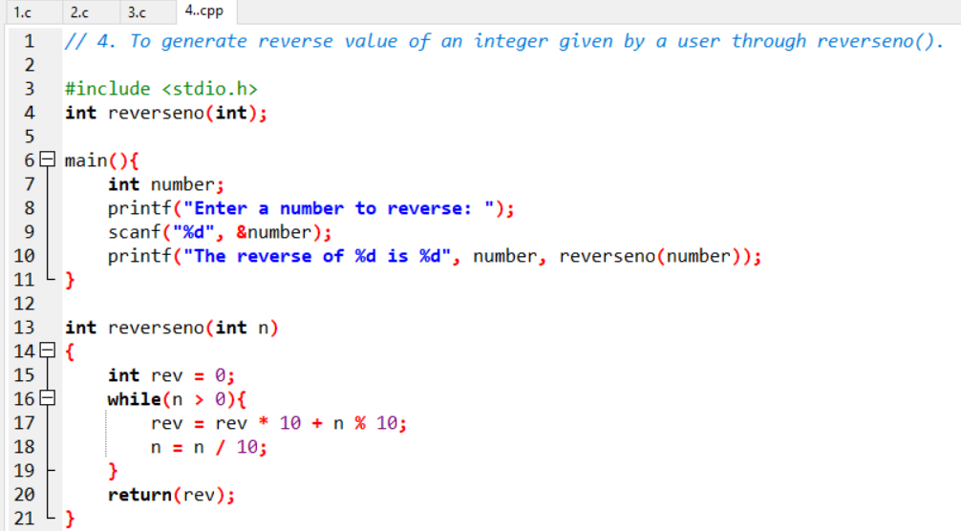

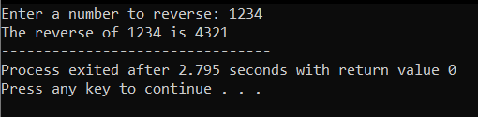

5.

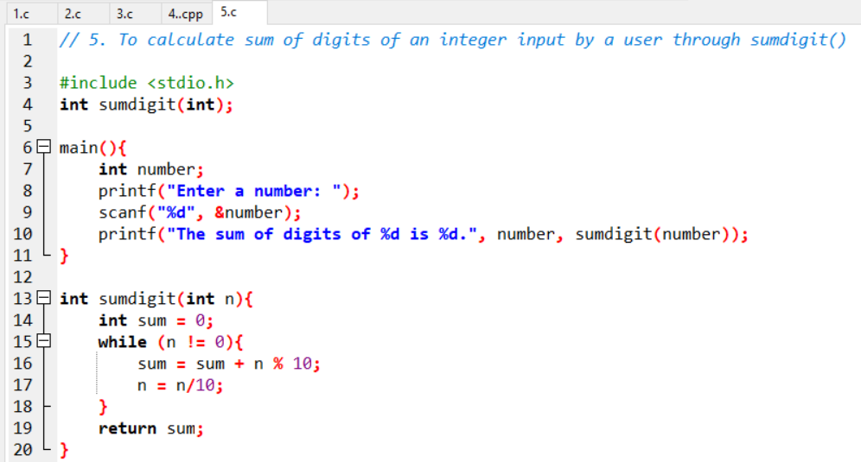

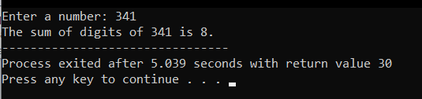

6.

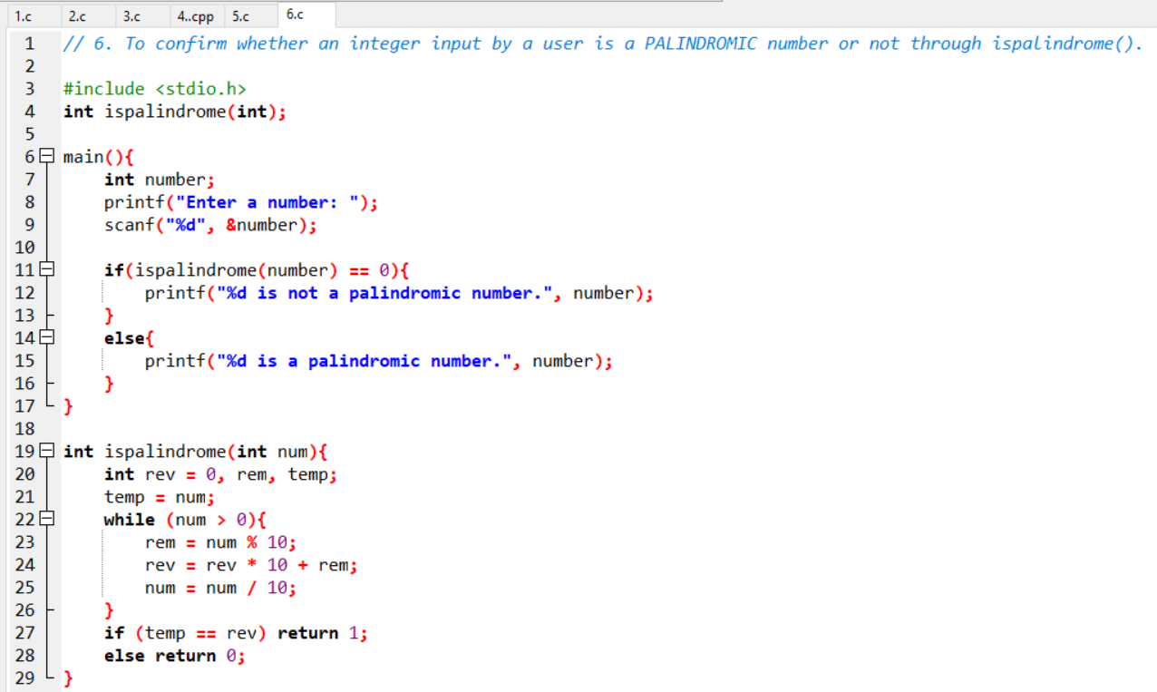

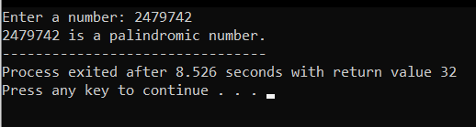

7.

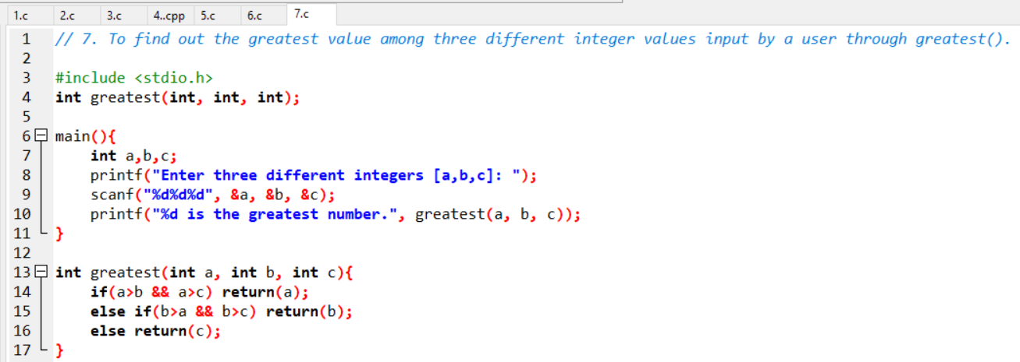 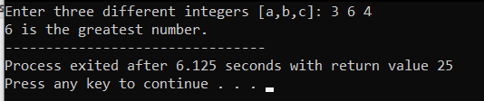

8.

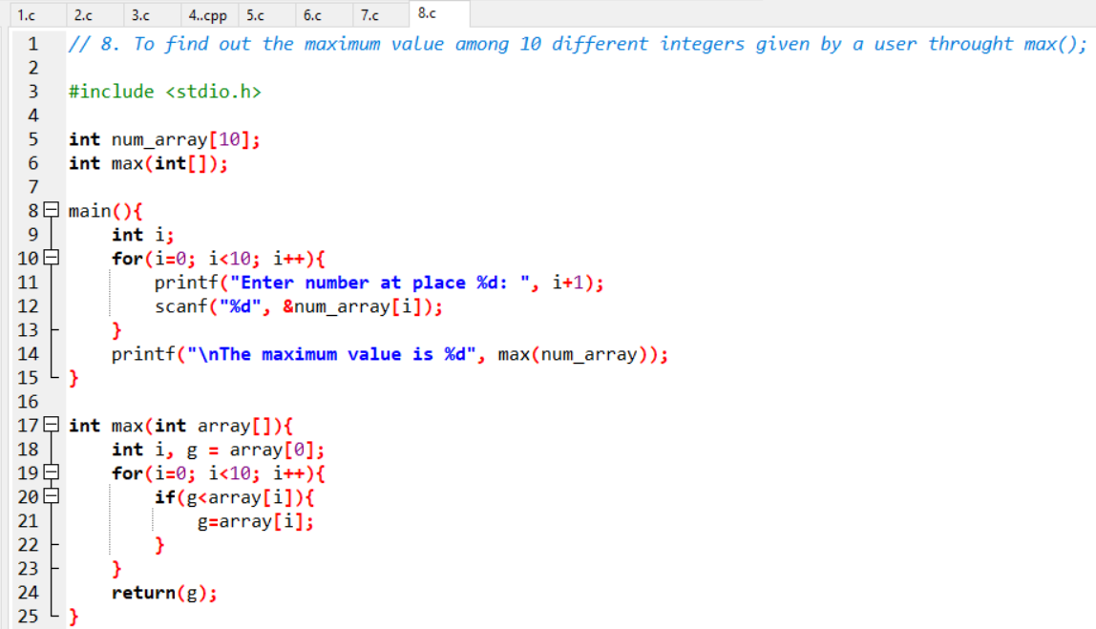

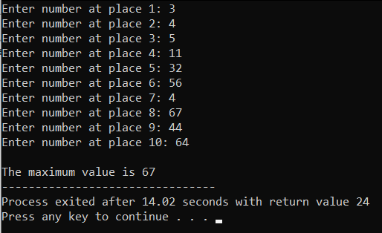

9.

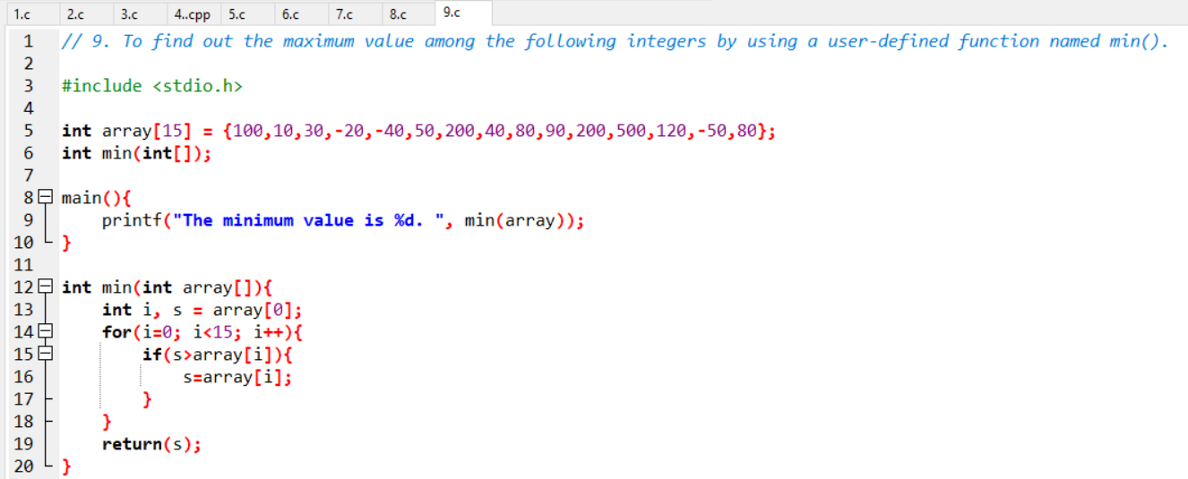 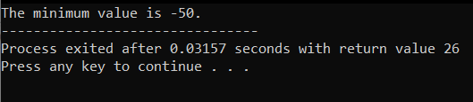.

10.

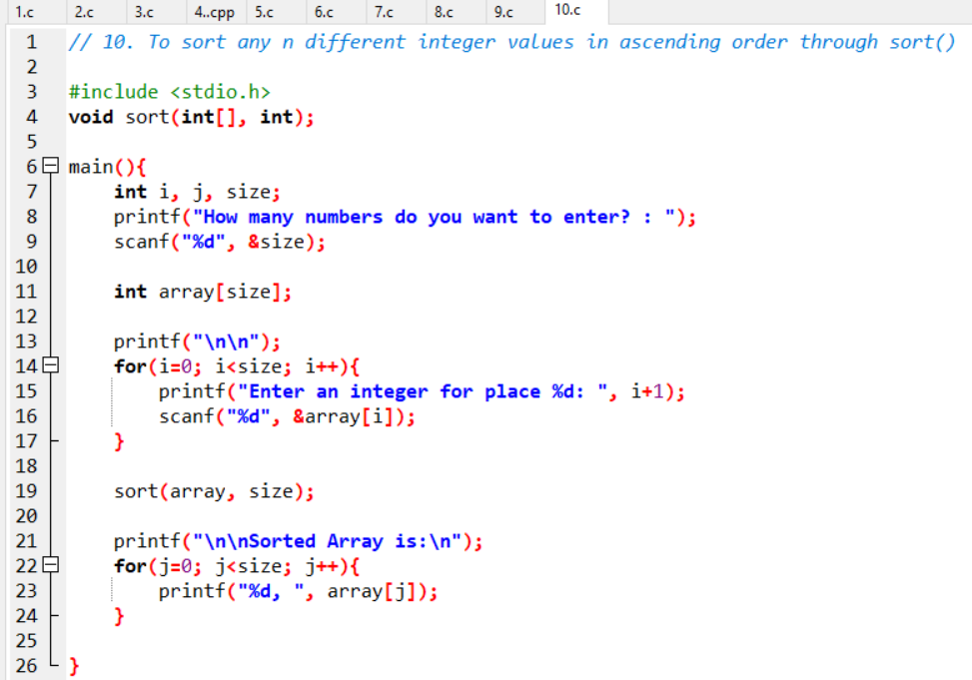 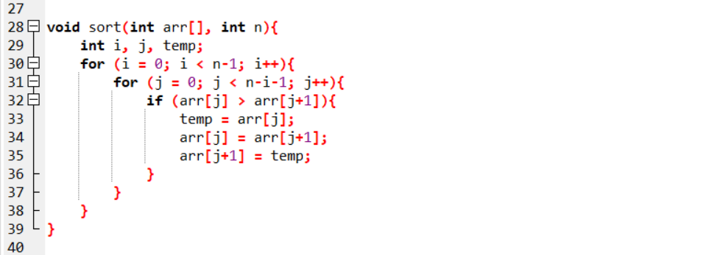 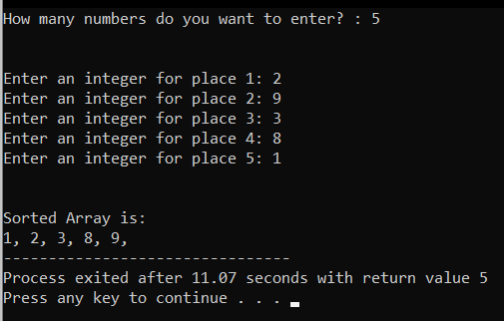

11.

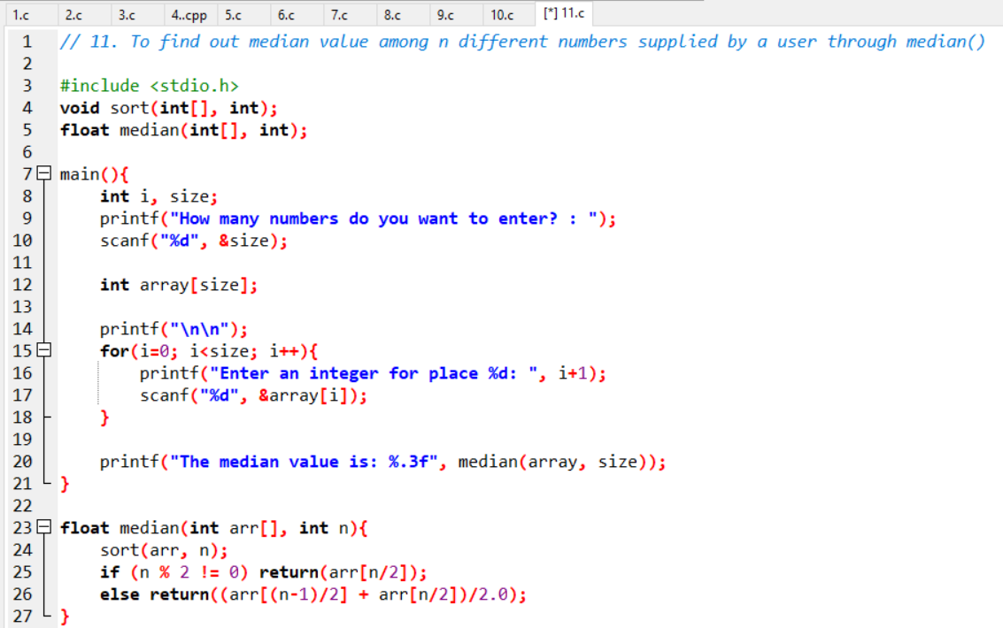 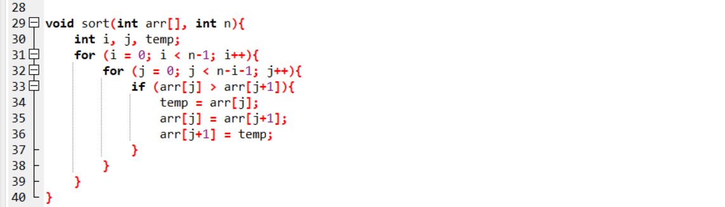 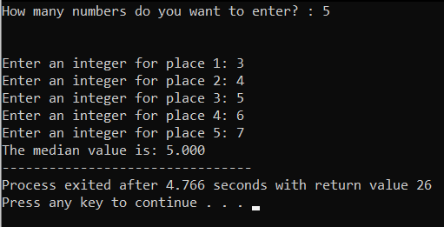

12.

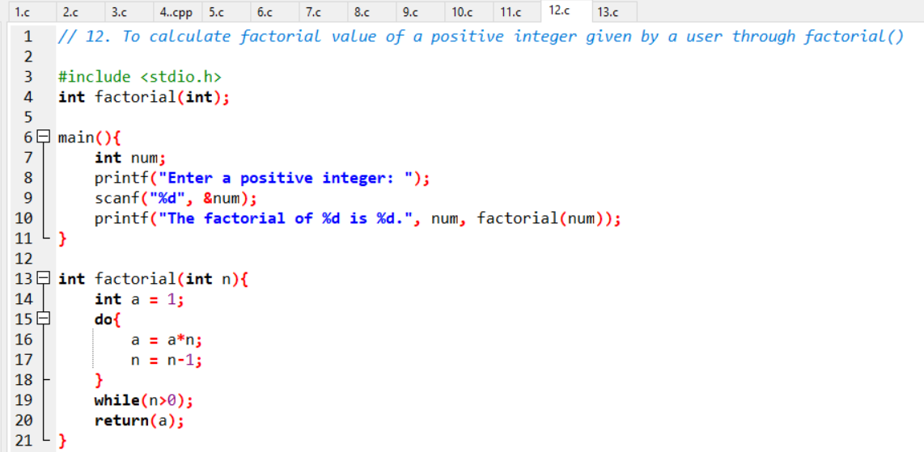 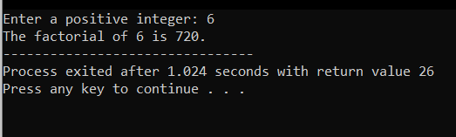

13.

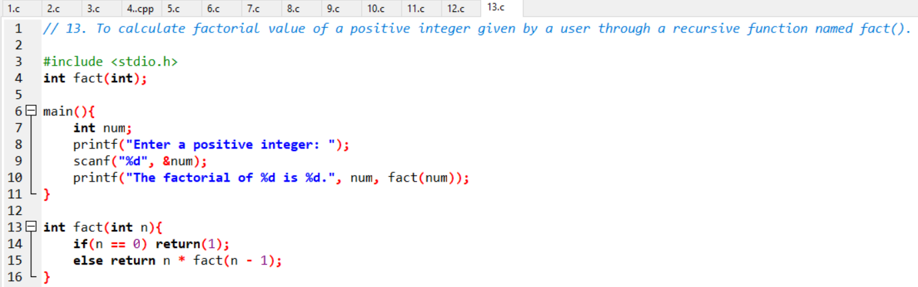 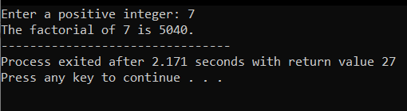

14.

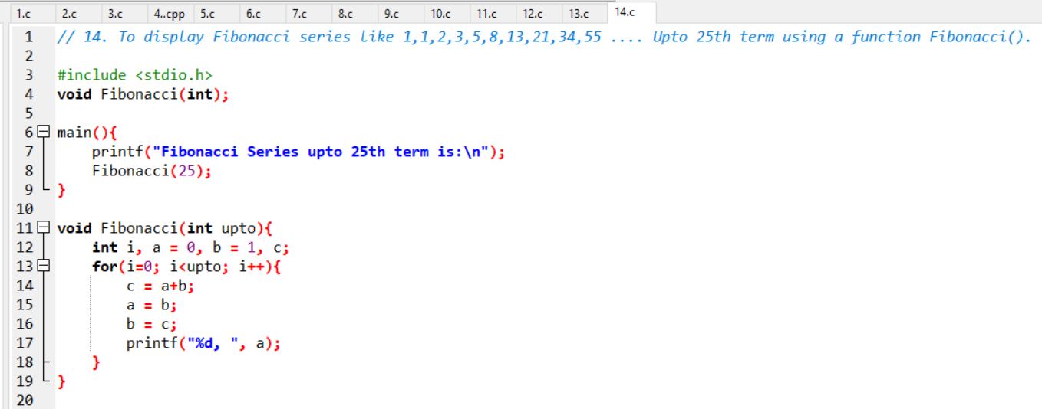 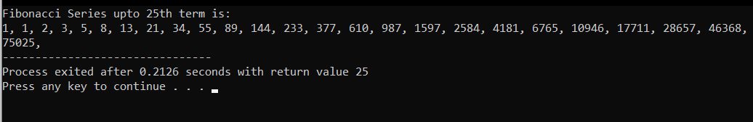

15.

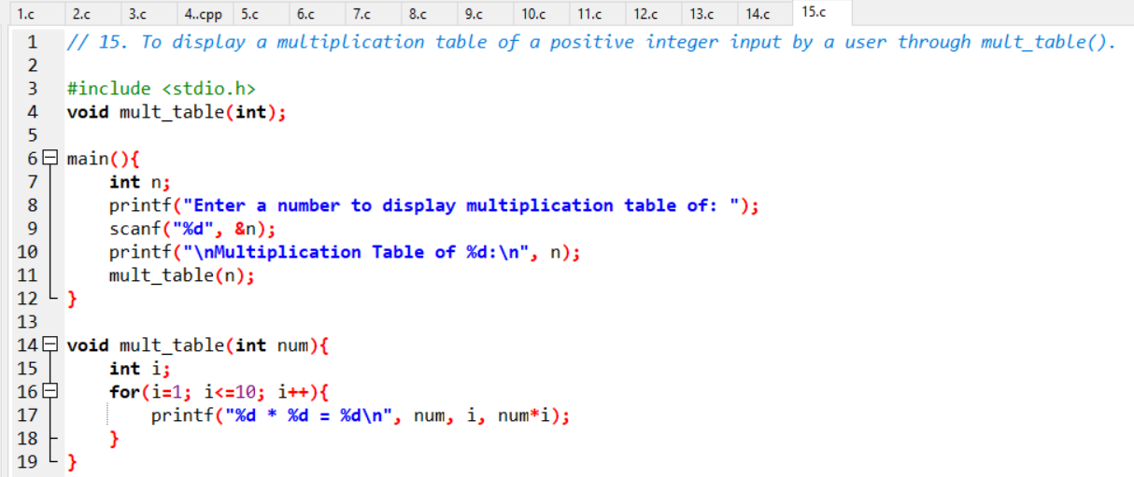 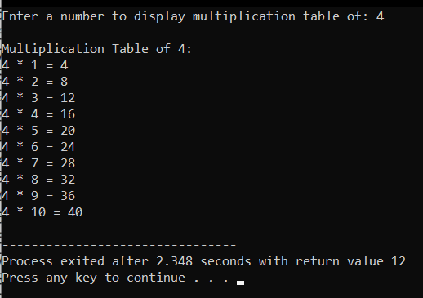

16.

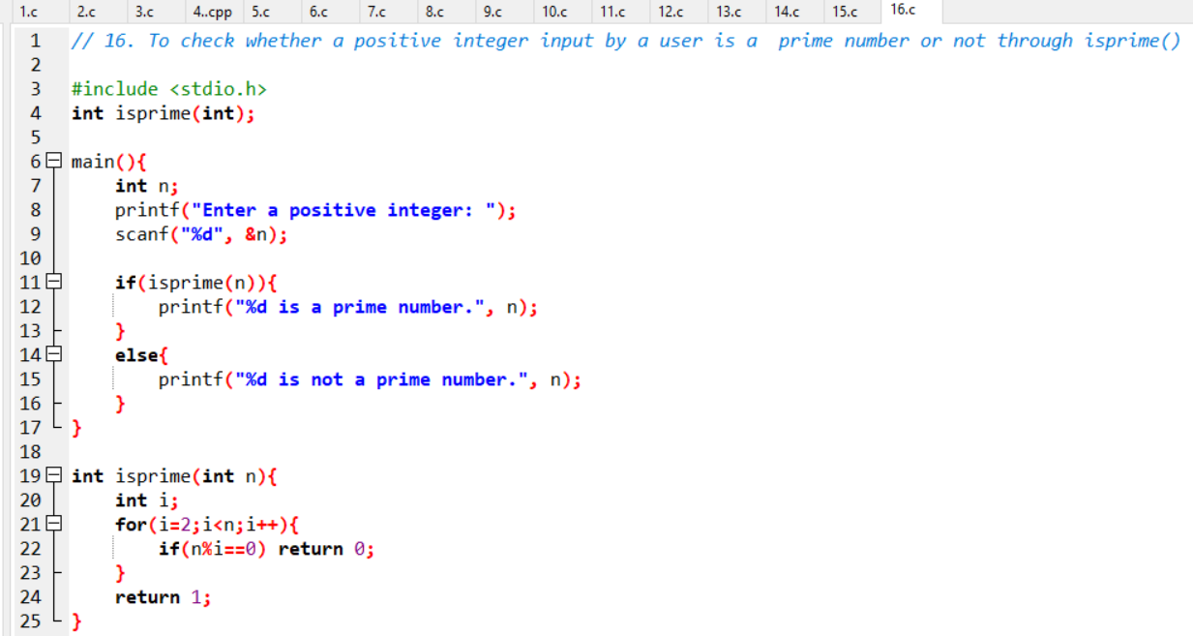 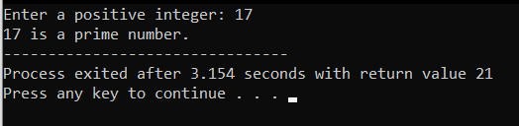

17.

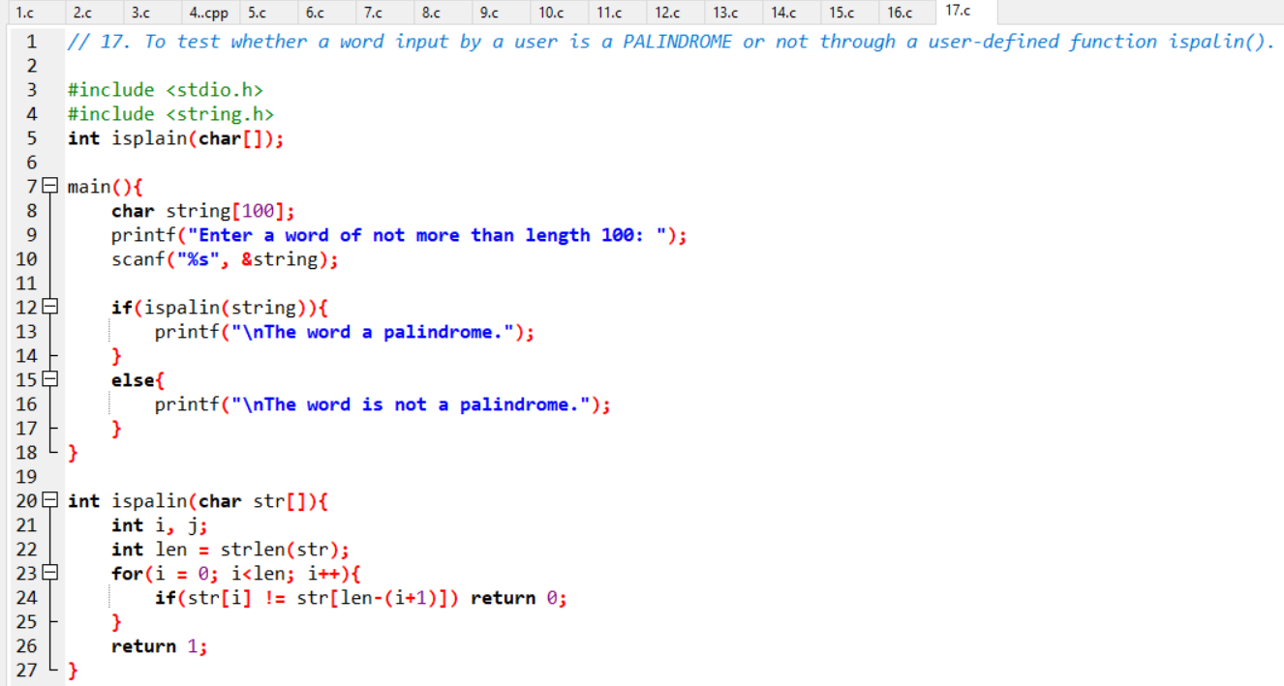 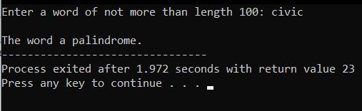

18.

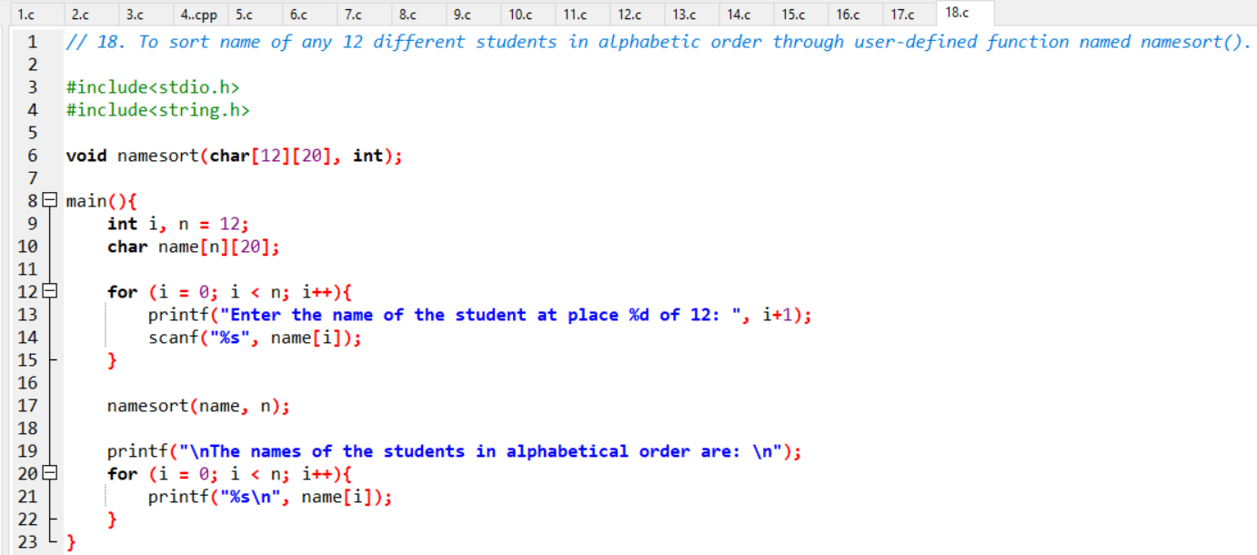 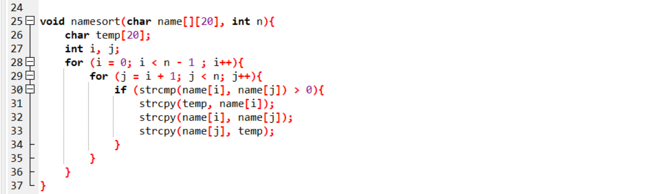 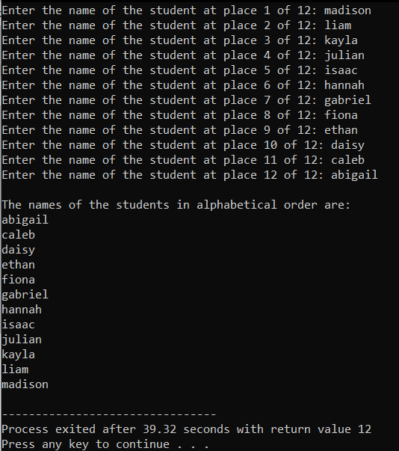

19.

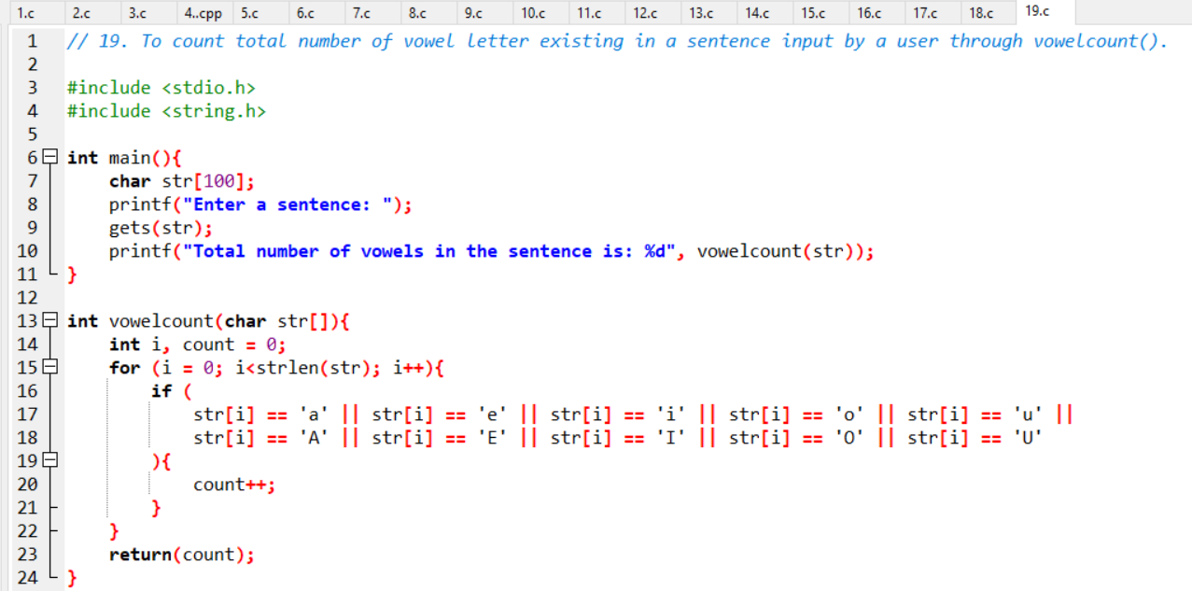 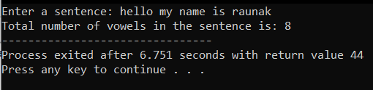

20.

